Worksheet 1 evidence log

Mert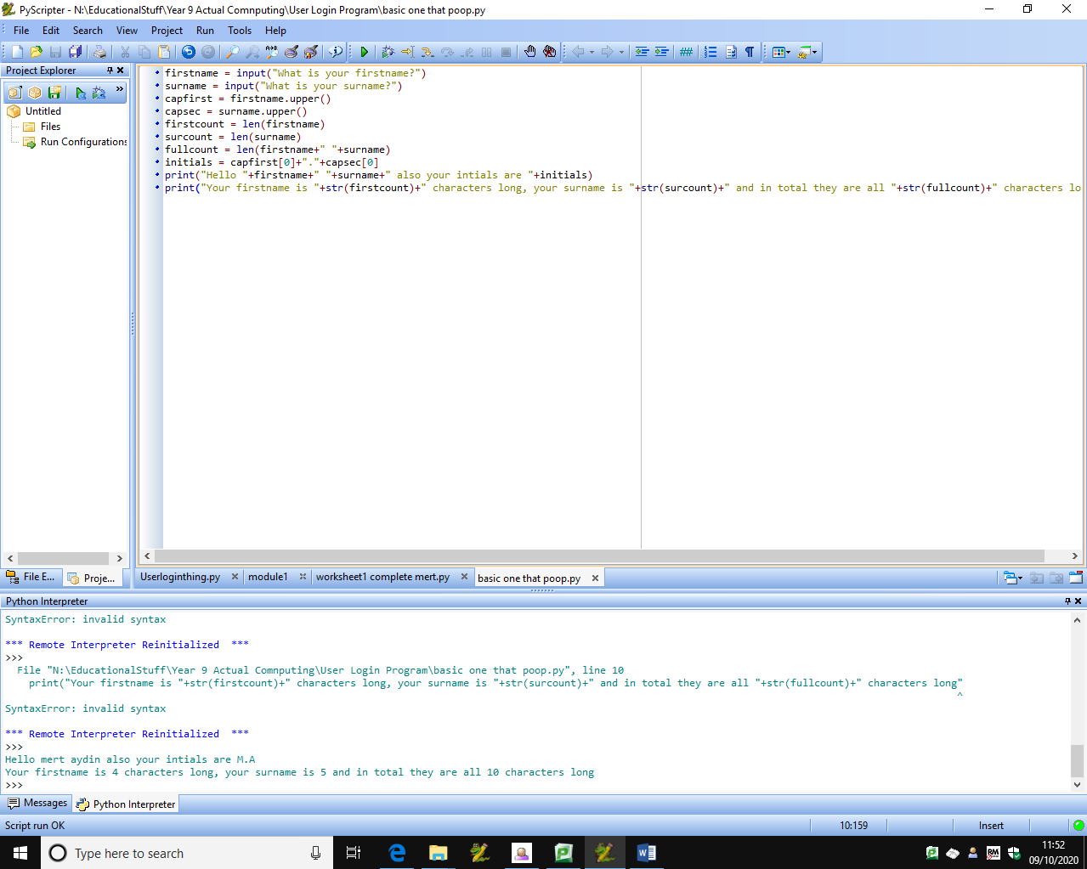

firstname = input("What is your firstname?")

surname = input("What is your surname?")

capfirst = firstname.upper()

capsec = surname.upper()

firstcount = len(firstname)

surcount = len(surname)

fullcount = len(firstname+" "+surname)

initials = capfirst[0]+"."+capsec[0]

print("Hello "+firstname+" "+surname+" also your intials are "+initials)

print("Your firstname is "+str(firstcount)+" characters long, your surname is "+str(surcount)+" and in total they are all "+str(fullcount)+" characters long")